Business in Profile - Handybin Waste Services Recycling Facility

Handybin operates a state-of the-art recycling facility at the Coffs Coast Resource Recovery Park and employs and trains over 50 local people in collection, processing, education and administration roles.

The company, which has been servicing the Coffs Coast Region for the last 15 years is local, Australian-owned, and recycles more organics and recyclables than any other company on the North Coast.
Last financial year, Handybin recycled almost 11,000 tonnes of material which saved electricity equivalent to the annual usage of 8,840 homes. That’s about 25% of the households on the Coffs Coast.
For businesses wishing to reduce their environmental impact, Handybin specialise in commercial and industrial complete waste management solutions. Their best practice recycling services divert the maximum amount of material from landfill, and thereby help you to reduce your environmental footprint.
Paper and cardboard constitutes on average about 70% of business waste. Throwing paper and cardboard in the garbage is like throwing money away. Simon Booth of Handybin Waste Services says “There is still a large percentage of cardboard and paper that is ending up in business garbage bins that could be easily be recycled into new products. Why pay high tip fees to dispose of this valuable resource?” By taking advantage of cheap paper and cardboard collection services businesses can save money and reduce their environmental impact.

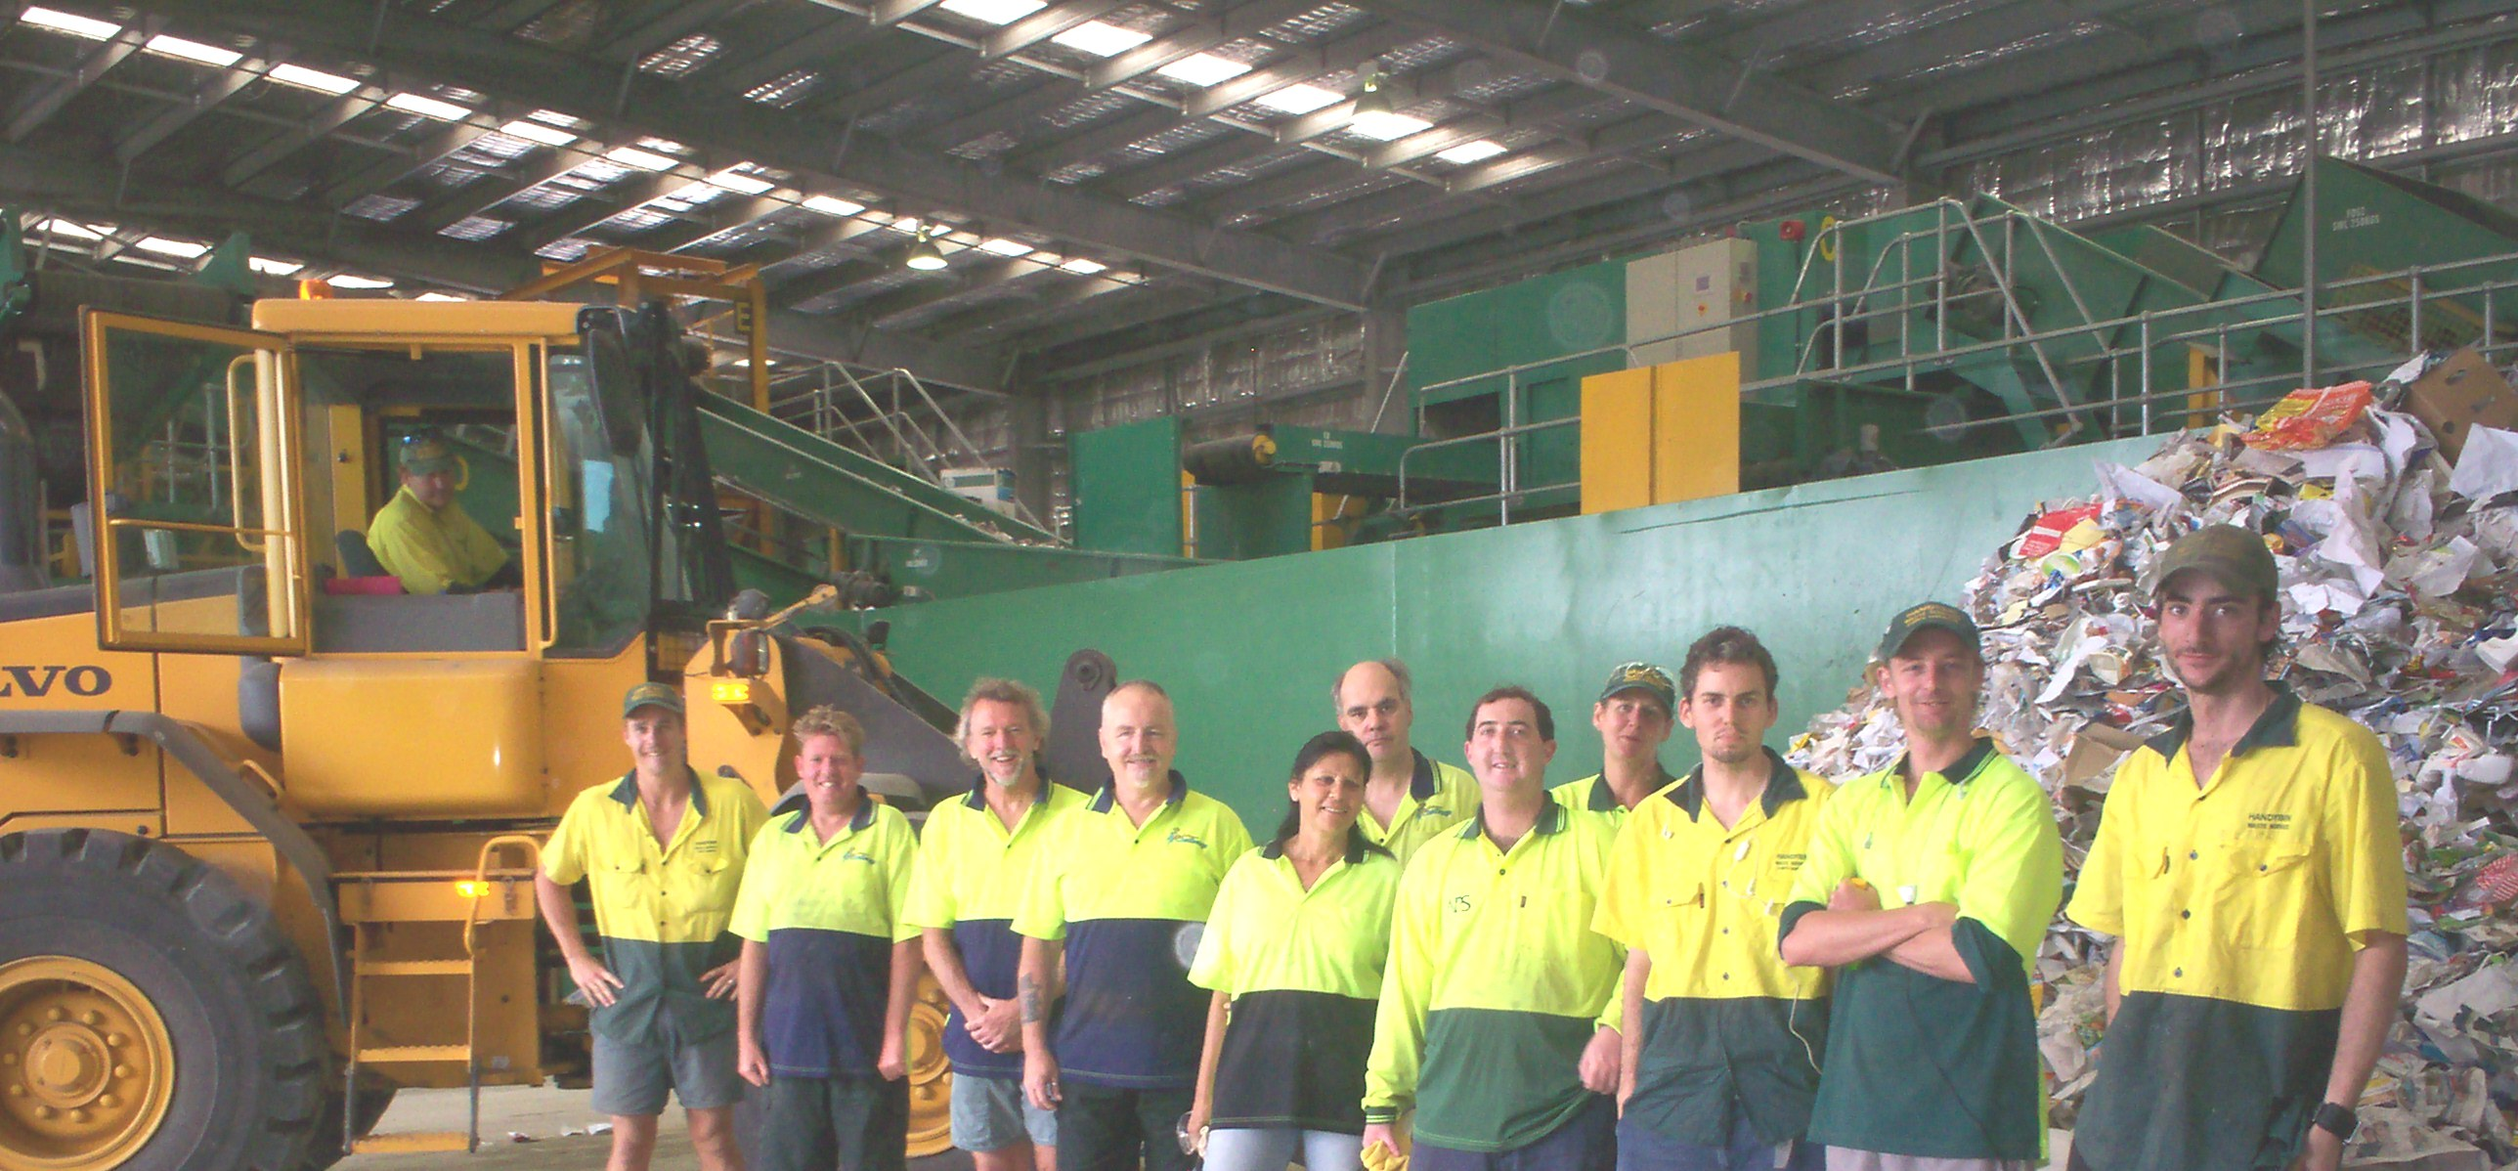
Staff Profile:

Handybin Recycling Facility processes about 60 tonnes of material every day from homes and businesses on the Coffs Coast which is hand-sorted by 9 sorters and packed and loaded by 4 operators.

Clair Cherry is one of the sorters on staff at Handybin.

What do you do at the recycling facility?
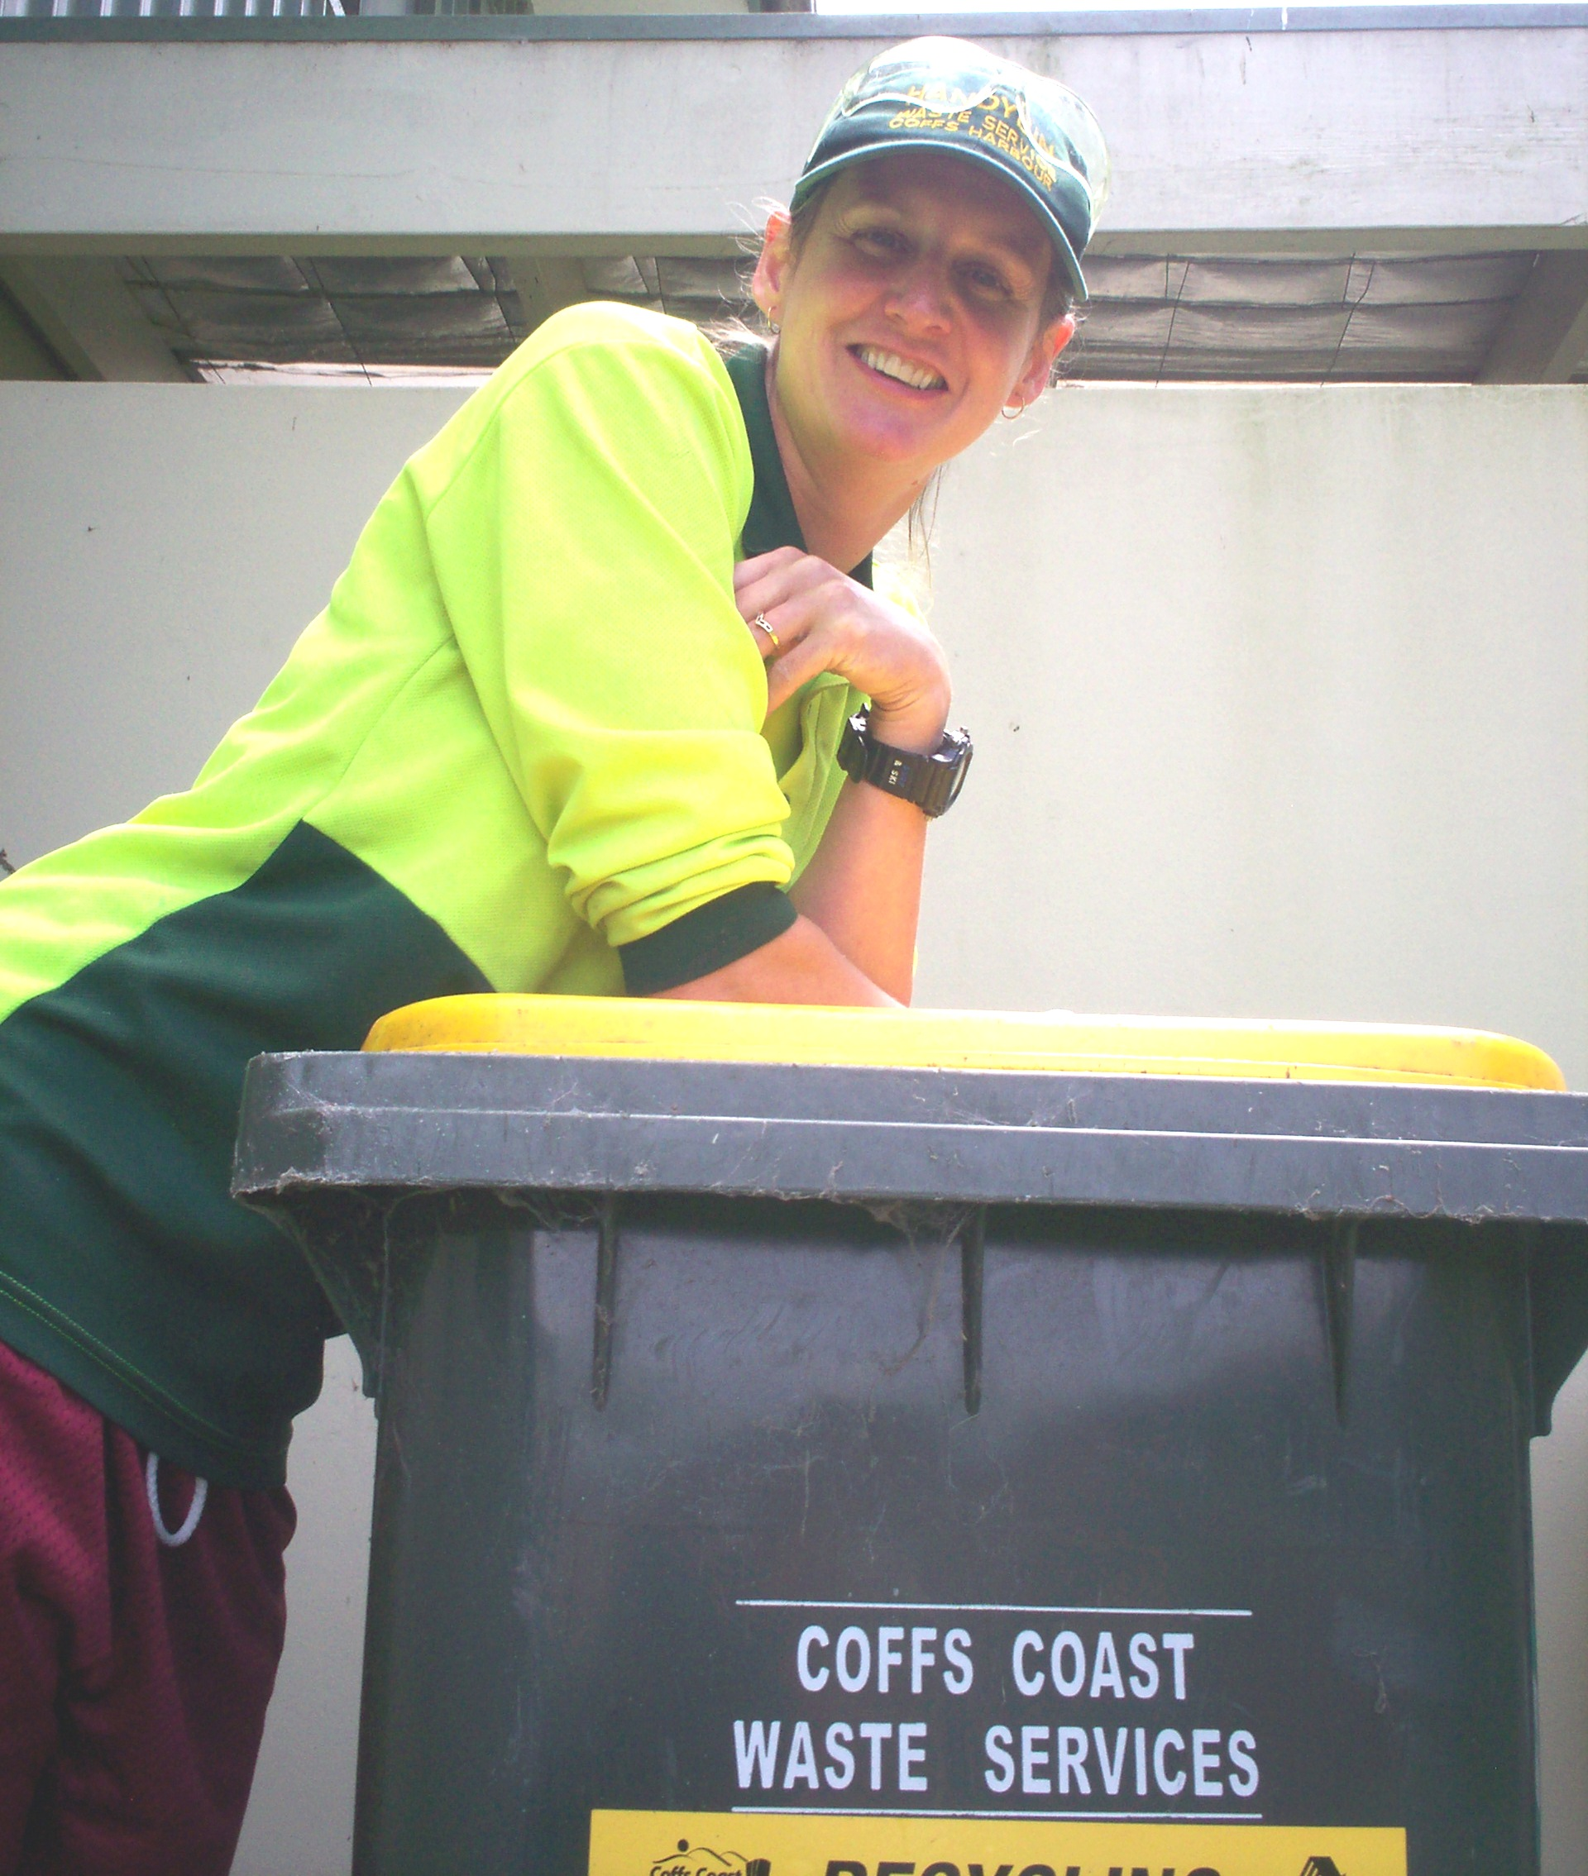“I sort various recyclables. Everyday I work on different recycling lines which include sorting cardboard; clear and coloured glass bottles and jars; milk bottles and soft drink bottles and other plastics as well as removing contamination.”

“The best thing about working at the recycling facility is that we’re doing something good for the environment. People can see us sorting when they come on a tour and get a better understanding of the process of recycling. We also have great working hours which means we are finished by early afternoon and can go surfing or whatever we like.”

What are some of the challenges of working at the facility?
“We come across some bizarre things that people mistakenly place in the yellow recycling bins. We have found dead animals such as puppies, galahs, cats, magpies and even a whole shark. There have been syringes, nappies and sanitary napkins in the bins. We pull about 150 nappies off the line each day which is pretty disgusting.”

What are some of the most interesting things that have been found on the line?
“Its amazing some of the stuff that ends up in the bins. We’ve had live pythons, a stuffed magpie and even a prosthetic leg.”

