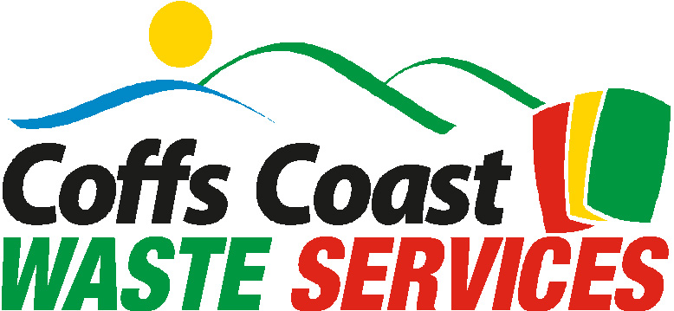

MEDIA RELEASE
5/6/09
WORLD ENVIRONMENT DAY

Recycling is one of the easiest things you can do to reduce your impact on the environment.

Each time you put out a full recycling bin is equivalent to saving 20Kg of greenhouse gas emissions.

But what if all your recyclables do not fit in the recycling bin? One of the most frequent comments from residents is that they don’t have enough room in their recycling bins.

Residents can order an extra large 360L bin, 50% bigger than the regular 240L wheelie bin through Coffs Coast Waste Services.

Please contact the Coffs Coast Waste Services Hotline on 1800 265 495

