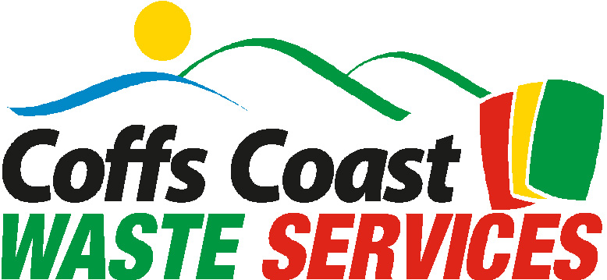

MEDIA RELEASE
28/7/08
Coffs Coast Recycling Statistics

Congratulations to all residents of the Coffs Coast on a fantastic recycling effort over the past twelve months.

The total product recycled was a massive 9,946 tonnes and took approximately 415 semi trailer loads to transport to markets. This included 7,565 tonnes of paper and cardboard, 513 tonnes of milk, beverage and mixed plastic, 1,499 tonnes of clear and coloured glass, 276 tonnes of steel cans and 93 tonnes of aluminium cans.

The one tonne paper and cardboard blocks alone, with a height and width over 1 metre and placed end on end would stretch over 15 kilometres. It is also the equivalent of saving 98,345 fully mature trees. The plastics, steel and aluminium blocks placed on top of each other would reach a height of nearly 2.5 kilometres.

In addition to these remarkable statistics the Environmental Benefits of Recycling Calculator equates the Coffs Coast recycling effort as :

- Saving 28,986 m3 of landfill space;
- Permanently removing 1,305 cars from our roads;
- Reducing the annual electricity usage of 8,800 households;
- Saving the annual water usage for 2,127 people;
- Total greenhouse benefits of 5,434 tonnes.
A terrific effort from all Coffs Coast residents and Coffs Coast Waste Services.

For further information or photo opportunities please contact Simon Booth on 0439604076.

