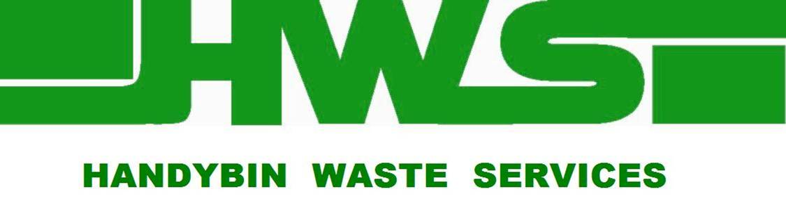

Media Release, 2008

The Coffs Ex Services Club is leading the way in minimising waste to landfill

The Coffs Harbour Ex-Services Club is doing its part in reducing waste to landfill through use of the 3-bin system in its operations.

The Club is separating all waste using yellow, green and red-lidded bins into: recyclables, organics (foodwaste) and garbage.

“The club is recycling approximately 84% of waste which is a phenomenal effort.” Gerry McGilvray from Handybin Waste Services said. “This is reducing the Club’s greenhouse gas emissions by around 1.6 tonnes per week.”

The club is utilising services which collect the three different waste types from wheelie bins three times a week. As a result of using the service, the Club has made savings on waste disposal costs and reduced Occupational Health and Safety issues associated with waste handling.

Recycled material is being processed at Handybin’s Materials Recovery Facility into new products and Organics put in the green bins is processed through the Resource Recovery Facility into compost.

Bob Dempsey, Maintenance Manager at Coffs Harbour Ex-Services Club said “use of the 3-bin system enables us to do something for the benefit of the environment while also meeting our own operational needs”.

