Karangi Public School wins the first Coffs Coast Waste Wise Award.
Karangi Public School has won the very first Coffs Coast Waste Wise Award for Excellence in Recycling. The award was presented to very proud school captains Chelsea Rose, Annie Rayment and Angus Field during a special assembly held at the school on Friday.
Coffs Harbour City Council’s Deputy Mayor, Cr Bill Palmer, congratulated the students for their recycling efforts stating that the school is a great example to all education facilities within the Coffs Coast Region.
“It’s a real pleasure to see our youth taking the initiative to recycle and do the right thing with their waste.”
Karangi Public School won the award under the category of Education Facilities, with 76% recovery of their total waste.
“Our teaching and support staff have a strong commitment to making our school waste-wise but the real credit for the award belongs to the students,” said Karangi Public School Principal, Mrs Kathryn Puddey.
Coffs Coast Waste Services have developed the Coffs Coast Waste Awards. These awards are sponsored by Handybin Waste Services and are designed to recognise organisations, both private and government, that are achieving high levels of recycling and recovery of their waste stream.
Three times per year and award will be presented to leading recyclers under the following categories:
- Education Facilities – public and private
- Tourism, Hospitality and Accommodation
- Business, Industry and Government

To be eligible for the major award in each category, the organisation must be achieving an average of recovery (ie – recycling and organics) of over 70% of their total waste stream.
The awards apply to all organisations in the Coffs Harbour, Bellingen Shire and Nambucca Shire that are using the Coffs Coast Waste Services collections
The award is also used to encourage more business and industry to ‘do the right thing’ with their waste and utilise the three bin system that is already used by residents in the region.
More and more public schools in the Coffs Coast region are recognising the importance of integrating environmental sustainability programs into the curriculum. We encourage your school to implement recycling and organics collections and education for your students.
Handybin Waste Services have educational resources that we can provide your school to help with maximising recycling and minimising contamination in your waste stream.
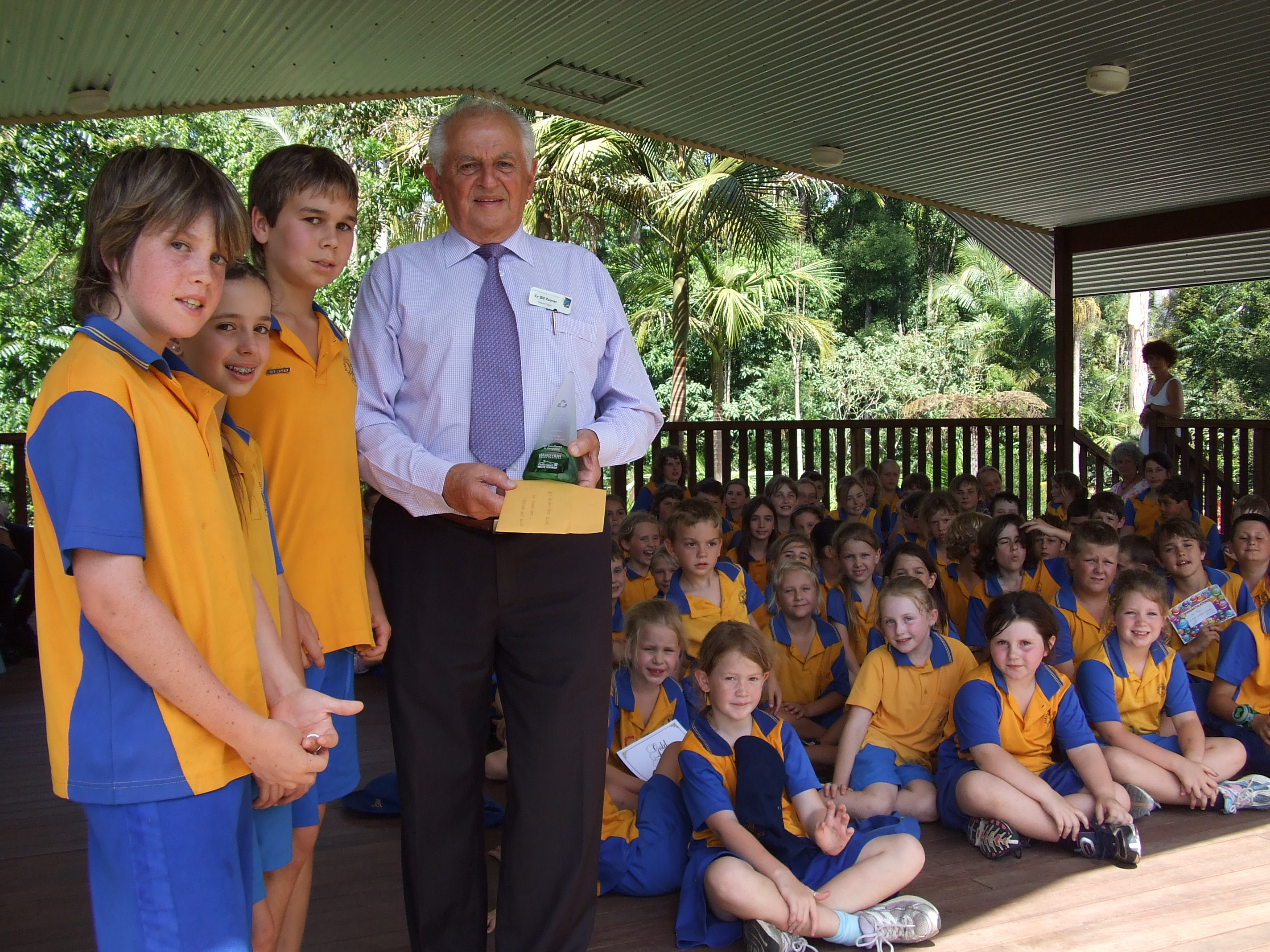To find out how to make your school waste wise and find out more about how to qualify for a Waste Wise award, contact Coffs Coast Waste Services today on
1800 265 495.
www.handybinwaste.com.au

